H.T No
Regulations:
A14

Sreenidhi Institute of Science and Technology
(An Autonomous Institution)
Code No: 4A243/4AC43 Date: 26-Nov-2020 (FN)

B.Tech I-Year II-Semester External Examination, Nov/Dec - 2020 (Supplementary)
NETWORK ANALYSIS (ECE and ECM)

Time: 2 Hours Max.Marks:70

Note: a) No additional answer sheets will be provided.
b) All sub-parts of a question must be answered at one place only, otherwise it will not be valued.
c) Missing data can be assumed suitably.

ANSWER ANY 5 OUT OF 8 QUESTIONS. EACH QUESTION CARRIES 14 MARKS.

1. | a) | State Kirchhoff’s Laws. | [7M]
 | b) | Obtain the equivalent resistance R_{ab} in the below circuit.  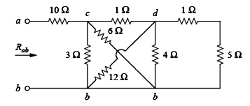 | [7M]
2. |  | Explain with examples dependent and independent sources. | [14M]
3. |  | For the network shown in below figure, write a tie set schedule and then find all branch currents and voltages.  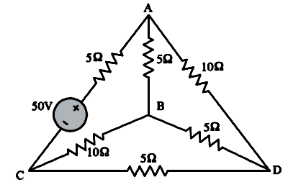 | [14M]
4. |  | A capacitor of 35µF is connected in series with a variable resistor. The circuit is connected across 50Hz mains. Find the value of resistor for a condition when the voltage across the capacitor is half the supply voltage. | [14M]
5. |  | For the circuit shown in fig find i_{o} when V_{s} = 24 v and V_{s} = 12v.  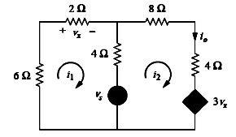 | [14M]
6. |  | Determine the Y-parameters for the network shown in below figure.  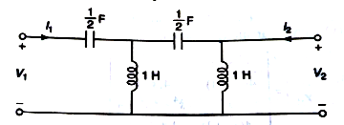 | [14M]
7. | a) | Find the characteristic impedance, cut-off frequency and pass band for the network.  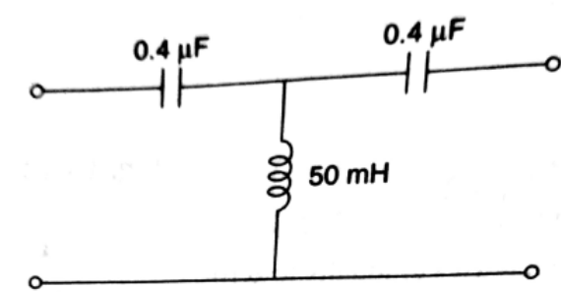 | [7M]
 | b) | Design an m-derived T-Section low-pass filter having cut-off frequency of 800Hz, design impedance of 500Ω and frequency of attenuation of 1000Hz. | [7M]
8. | a) | In the network the switch is closed at t = 0. With the capacitor uncharged, find value for i, and at t = 0⁺.  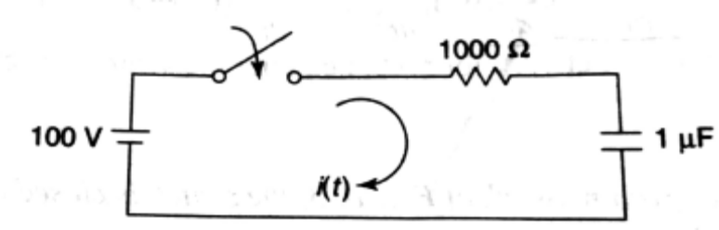 | [7M]
 | b) | In the given network, the switch is opened at t = 0. Solve for v, and at t = 0⁺.  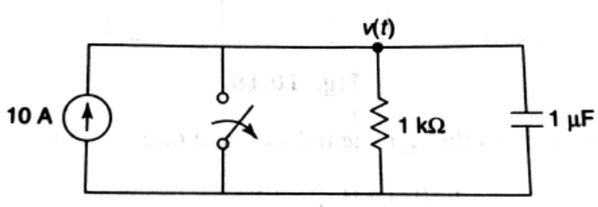 | [7M]

-- 00 -- 00 –

